Meeting at USH During Covid Times
The importance of human and community connections has only grown stronger as the Covid-19 pandemic continues. Recognizing that we will be living with this reality for the foreseeable future, the Board is pleased to open our grounds and Fellowship Hall for small groups of up to 15 people.
Connecticut’s data-driven approach to public health has allowed CT to have some of the lowest infection rates in the country, and CT’s approach also gives us the ability to make choices that find a balance of safety and connection.
Recognizing that the public health situation is likely to fluctuate in the colder months, our USH safety guidelines come from Connecticut business re-opening protocols and real-time public health data. We are also keeping group sizes small on purpose. This approach will allow us to adapt based on the reality of our local health status and help each person and groups to have up-to-date information to decide whether you choose to meet in person or virtually. If the health situation in Connecticut changes dramatically, we will re-evaluate our policies for the health and safety of all. Refer to pages 3-4 of this packet for details.
Health & Safety First: Please know that our most important consideration is the health and safety of members, friends and staff. We will count on each other to safeguard the well-being of all. Each group must ensure that safety protocols are followed. We recommend that folks over the age of 65 or with other health conditions to continue to stay home and stay safe.
Scheduling: You will need to schedule your gathering with Rayla and Buffie. Requests can be made for outdoors or indoors in Fellowship Hall only. Air handling capacity has been increased for Fellowship Hall, including the lower level rest rooms. Please schedule your gathering at least 5 days in advance using the Meeting Request form in this packet.
Planning your meeting: Please share this packet with your group before your meeting. Please be mindful of how to be inclusive of people who aren't comfortable or able to join in person. Meeting coordinators are asked to have conversations among the group members to ensure potential exclusion concerns are addressed prior to being onsite. We are working on a “Zoom link” for the large television screen which we hope will be available in November. Your group may choose to bring in your own laptops/tablets and host a Zoom meeting to include members who will not attend in person.

Covid-19 Meeting Requirements
- Masks are required to be worn at all times while in the building and maintain 6ft distance.
- If anyone in your group is diagnosed with Covid-19, notify the Office Administrator and discontinue meeting for 2 weeks.
- USH will provide hand sanitizer and cleaning supplies. Groups are responsible for bringing their own masks and following all safety protocols.
- The Health Attestation and Release forms must be completed by all participants & left in Fellowship Hall.

Meeting Request Form

Requestor Name:
Requestor email & phone number:
Name of Group/Meeting:
Dates Requested:
Times Requested (start/end):

Purpose of Meeting:

Requested Meeting location:
If outdoors, specify location.
If indoors, meetings are only held in Fellowship Hall.
Will you need the large television in Fellowship Hall? | Currently, the Meeting House cannot provide a “Zoom link” on the large television screen, but we are working on this. Your group may bring in your own laptops/tablets and host a Zoom meeting.
Will you be involving other people as instructors or coordinators? If so, who are they?
Anything else we should know?

Send this form and the Safety Protocols Certification to Rayla Mattson at dre@ushartford.com and Buffie Pinney at hartforduusociety@gmail.com. You will receive a response to your request within 5 business days.

Connecticut Safety Protocols

Step #1: Review the map of Average Daily Rate of Covid-19 Cases by Town and identify the color code of the town where you live.

Step #2: Review the CT Color Coded Response Framework and corresponding guidance for the Individual and Organized Group Activities
to help decide about your personal participation.

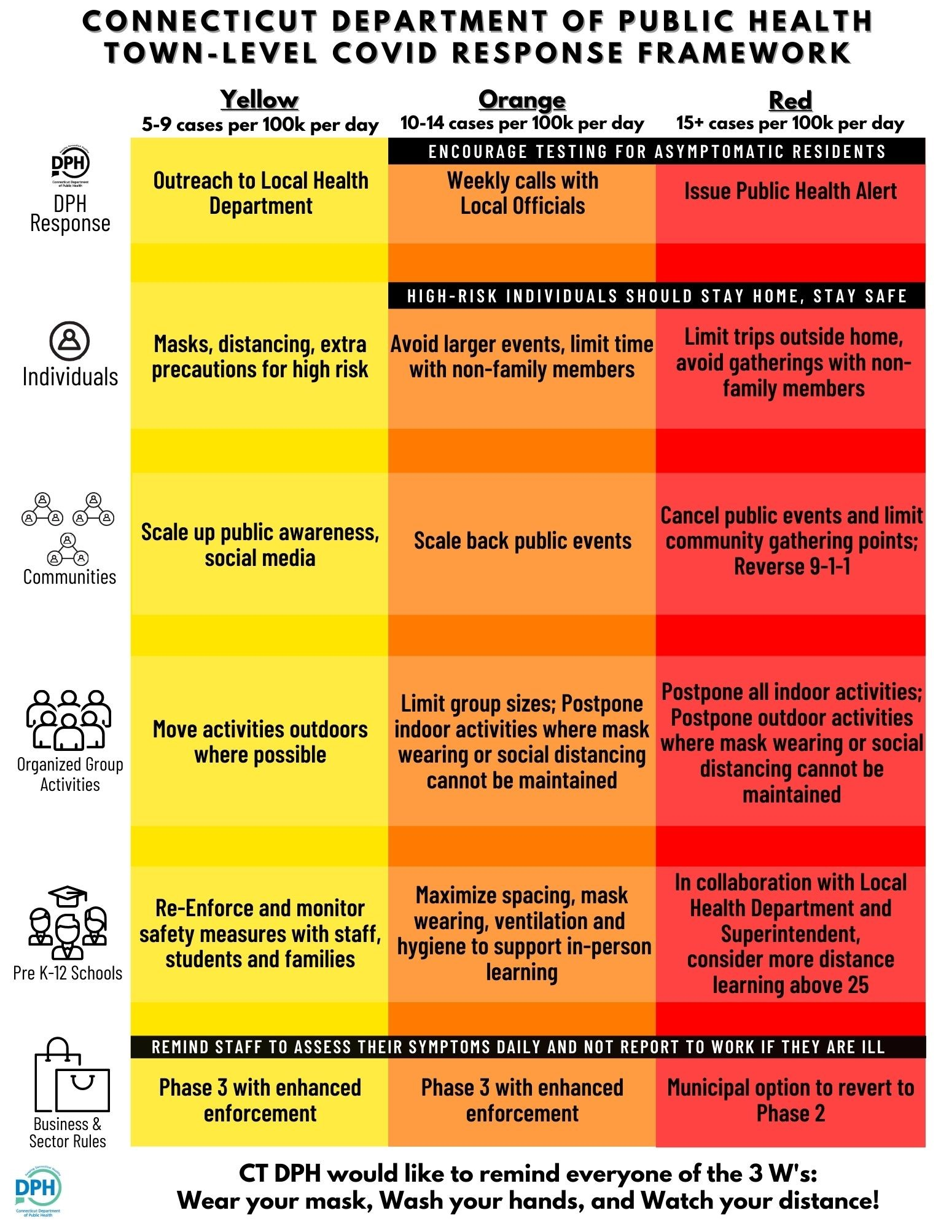

USH Safety Guidelines
aligned with Connecticut Health & Safety Guidelines for Businesses

Each meeting group must ensure all participants maintain the following safety protocols:

- No more than 15 persons will be present at the meeting/gathering.
- Attendees shall remain 6 ft apart, excluding immediate family members, caretakers, and household members.
- While indoors, all event participants shall wear a facemask or cloth face covering at all times that completely covers the nose and mouth.
- Building access is limited to lower level Fellowship Hall and lower level restrooms only due to increased air circulation. We recommend 1 person at a time in the lower level multi-use bathrooms. Use of any rooms or restrooms in the Sanctuary-level ambulatory is not permitted.
- Each participant completes the (a) Health Attestation for each meeting and (b) Release Form (one time only). Forms can be left in Fellowship Hall.
- Maintain a list of all participants in attendance for contact tracing, if needed.
- Individuals may bring their own drinks or food for personal consumption. No refreshments can be served in way that requires sharing of food or utensils. USH kitchen supplies (reusable mugs, plates, glasses, etc.) are not available for use at this time.
- Groups will wipe down high touch surfaces used by the group with disinfecting wipes/spray (table surfaces, door handles, light switches) prior to leaving the building. Hand sanitizer will also be available for use.
- Groups will not sing. Unfortunately, singing involves an increased risk of airborne spread of the virus through the air because singing is a more propulsive exhalation of air and the singer is also inhaling more deeply with each breath.

OUTDOOR ONLY:
- All event participants shall wear a facemask or cloth face covering at all times unless they are sitting outside more than 6 feet apart and/or with their household.

Health Attestation

for each in-person meeting – printed forms available in Fellowship Hall

- Have you experienced COVID-19 CDC-defined symptoms including cough, shortness of breath, or any two of the following symptoms in the past 7 days: Fever, Chills, Repeated shaking with chills, Muscle pain, Headache, Sore throat, and/or New loss of taste or smell?
___ Yes ___ No
- Have you or anyone in your household tested positive for Covid-19 in the last 21 days or been exposed to someone with a positive Covid-19 test in the past 14 days?

___ Yes ___ No

- Have you been in contact with someone who is sick or ill in the previous 14 days?
___ Yes ___ No
- Have you or anyone in your household traveled out of state in the past 14 days?
___ Yes ___ No

Name: _______________________________ Date: _____________

If any answers to the above questions are YES, please do not attend the meeting in person for the safety of others.
We encourage anyone 65 years or over with underlying COVID-19 susceptible conditions to stay home and remain safe.

USH Covid-19 Release

One-time for all in-person participation – printed forms are in Fellowship Hall

The novel coronavirus, COVID-19, has been declared a worldwide pandemic by the World Health Organization. As a result, federal, state, and local governments and agencies recommend social distancing and have, in many locations, prohibited the congregation of groups of people.

We are doing everything we can to be compliant with all regulations and ensure your safety. We have put in place preventative measures to reduce the spread of COVID-19, but we cannot guarantee that you or family members will not become infected with COVID-19.

By participating in programs, services, and activities of Unitarian Society of Hartford, you agree to the following:

On behalf of yourself and your children, you hereby release, covenant not to sue, discharge, and hold harmless Unitarian Society of Hartford, its employees, agents, and representatives, of and from all liabilities, claims, actions, damages, costs or expenses of any kind arising out of or relating to your participation in our programs, services or activities. You understand and agree that this release includes any claims based on the actions, omissions, or negligence of this organization, its employees, agents, and representatives, whether a COVID-19 infection occurs before, during, or after participation in any such program, service or activity.

Signature: ___________________________________

Printed Name: ________________________________

Date: ____________________

You only need to sign this document one time and it applies to participation in any in-person meetings or gatherings at USH.

